**BWT Task-02 Exercise**

**Submitted By: Abduhu Khan**

**Q1**

**Write a query to get data having length of Rna structures more than 12 with them being added after 2008.**

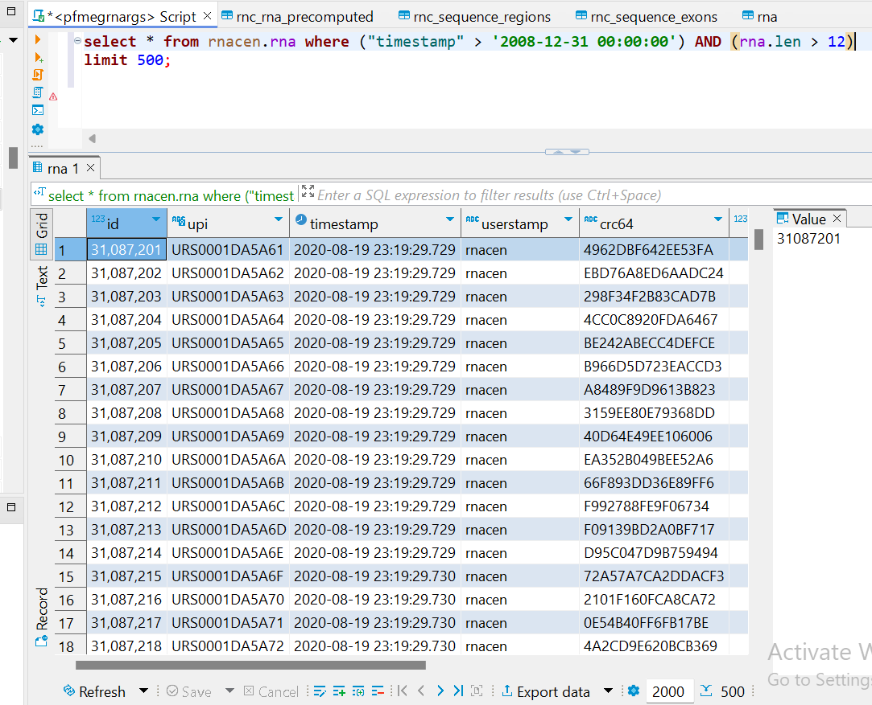

The condition of limit 500 has been added because of large result set achieved after executing query. There are more rows returned instead.

**Q2**

**How many pre computed RNA are present that are still active and got their last release update before 2022?**

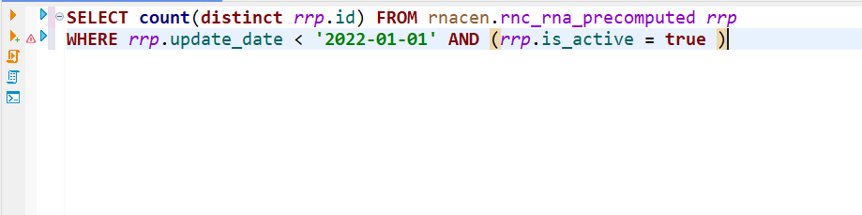

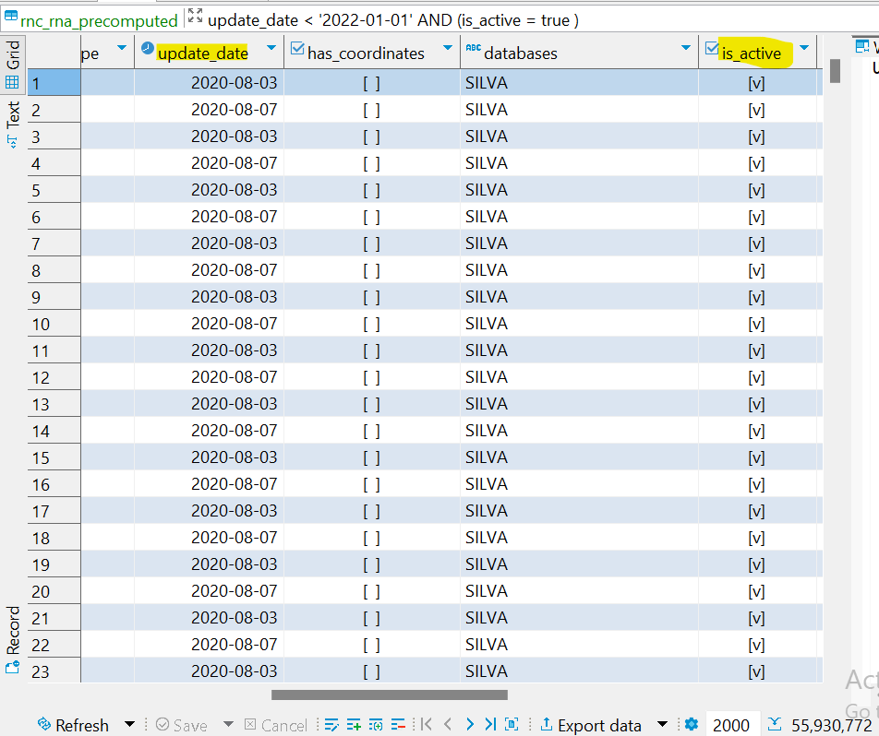

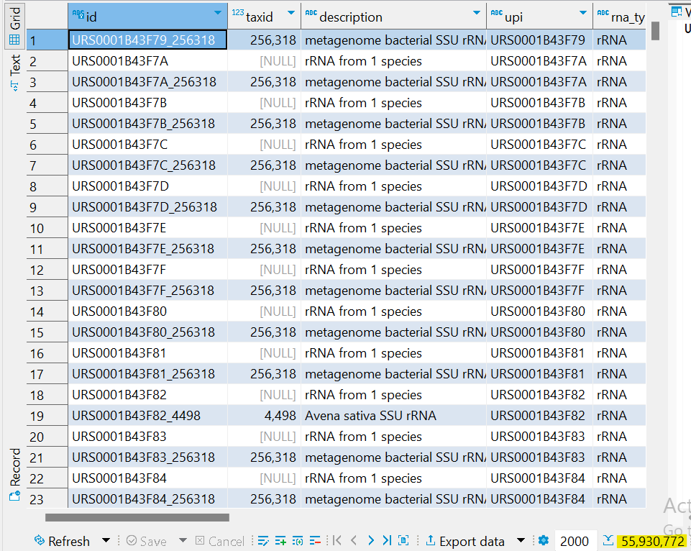

The highlighted number at the bottom right corner (55,930,772) tells the number of rows returned based on the conditions of query that are all those pre-computed RNA that are active and have last update before 2022.

**Q3**

**How many total pre computed RNA records for snoRNA and tRNA were recorded in 2011, 2016, 2014, and 2020?**

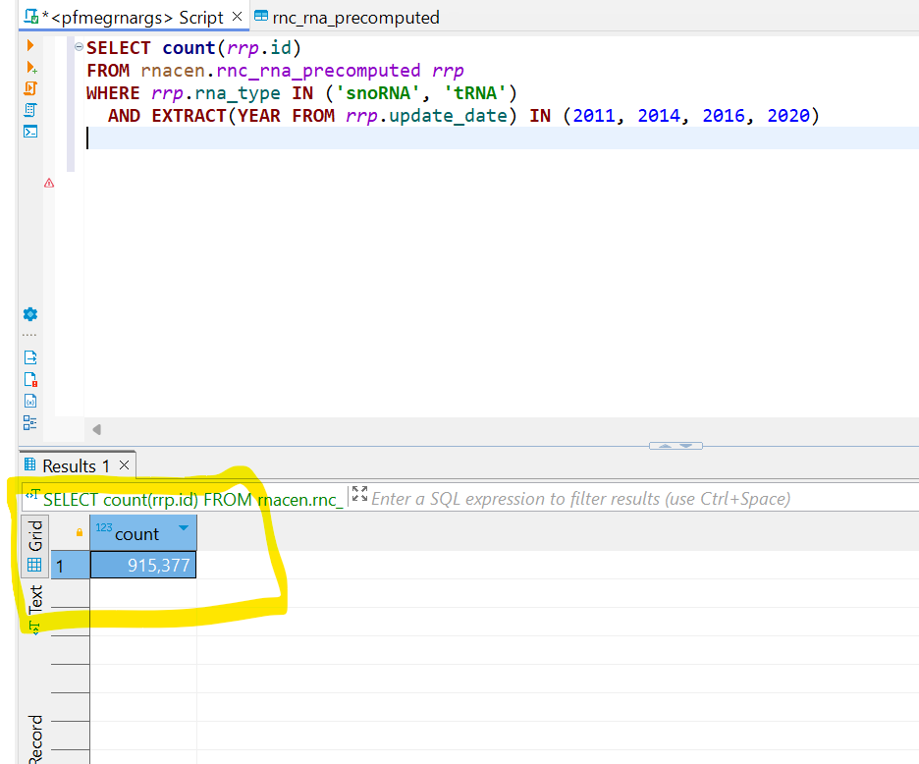

**Q4**

**Can you give me the names of all databases built for RNA with minimum length other than 100, 200, 300, 400, and 15?**

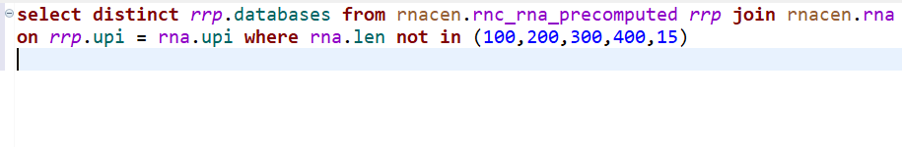

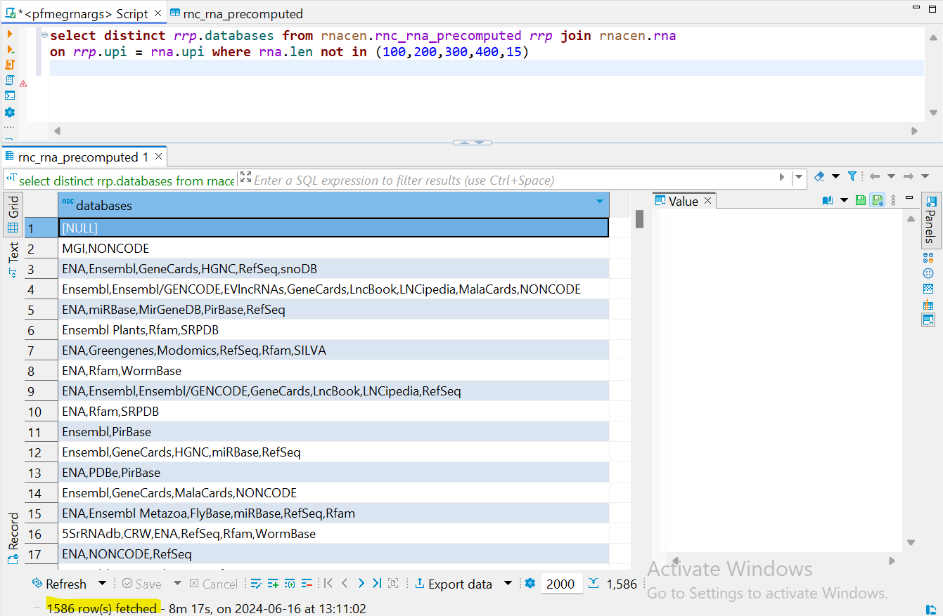

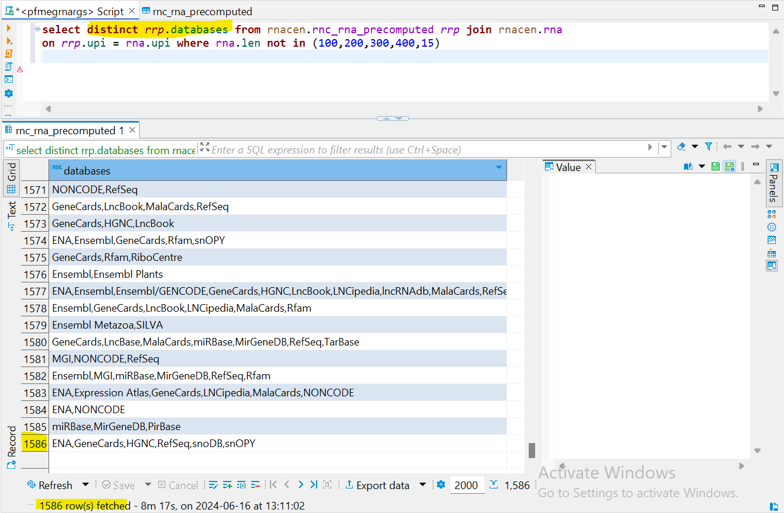

**Q5**

**Can you get complete 500 records of sequences for active regions and name your column as myregions in which you are getting the region name column value. Then tell me what different chromosomes with exon_count we have for regions including center, east and north using the name you set for your column?**

